**Test for Configuration and deployment**

**Aim:**  To famialirize tools configuration and deployment testing

**Description:**

The intrinsic complexity of interconnected and heterogeneous web server infrastructure, which can include hundreds of web applications, makes configuration management and review a fundamental step in testing and deploying every single application. It takes only a single vulnerability to undermine the security of the entire infrastructure, and even small and seemingly unimportant problems may evolve into severe risks for another application on the same server. In order to address these problems, it is of utmost importance to perform an in-depth review of configuration and known security issues, after having mapped the entire architecture.

Proper configuration management of the web server infrastructure is very important in order to preserve the security of the application itself. If elements such as the web server software, the back-end database servers, or the authentication servers are not properly reviewed and secured, they might introduce undesired risks or introduce new vulnerabilities that might compromise the application itself.

For example, a web server vulnerability that would allow a remote attacker to disclose the source code of the application itself (a vulnerability that has arisen a number of times in both web servers or application servers) could compromise the application, as anonymous users could use the information disclosed in the source code to leverage attacks against the application or its users.

The following steps need to be taken to test the configuration management infrastructure:

* The different elements that make up the infrastructure need to be determined in order to understand how they interact with a web application and how they affect its security.
* All the elements of the infrastructure need to be reviewed in order to make sure that they don’t contain any known vulnerabilities.
* A review needs to be made of the administrative tools used to maintain all the different elements.
* The authentication systems, need to reviewed in order to assure that they serve the needs of the application and that they cannot be manipulated by external users to leverage access.
* A list of defined ports which are required for the application should be maintained and kept under change control.

**Procedure:**

**tools:**

**1.WPScan**

Wpscan is a WordPress security scanner used to test WordPress installations and WordPress-powered websites. This is a command line tool used in Kali Linux. This tool can be used to find any vulnerable plugins, themes, or backups running on the site. It is usually used by individual WordPress site owners to test their own websites for vulnerabilities and also by large organizations to maintain a secure website. This tool can also be used to enumerate users and perform brute-force attacks on known WordPress users. In this article, We are going to take you through different commands of wpscan tool, the most commonly used attacks on WordPress sites, and tips to defend against them. The below functionalities of this tool can be used from the point of view of a hacker or even just someone who wants to test if their WordPress site is secure enough.

* ***–url : (basic scan)***

*wpscan –url IP_ADDRESS_OF_WEBSITE*

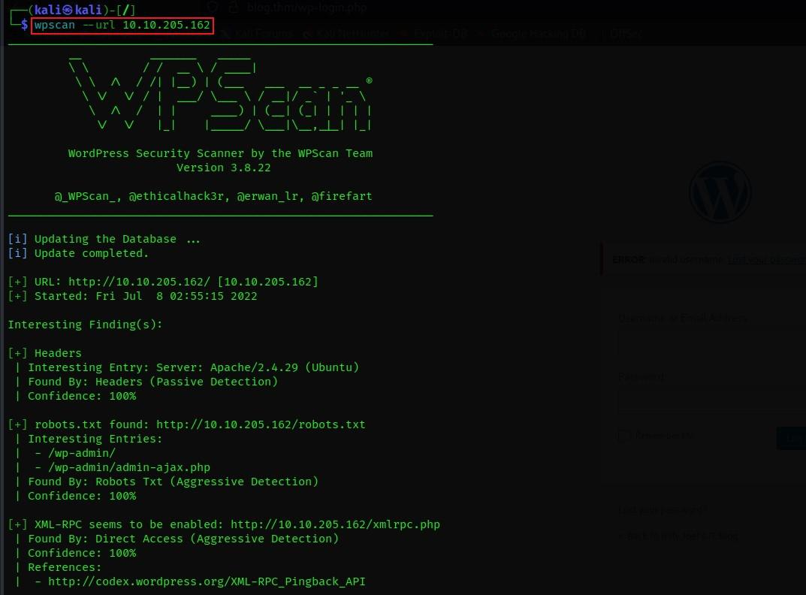

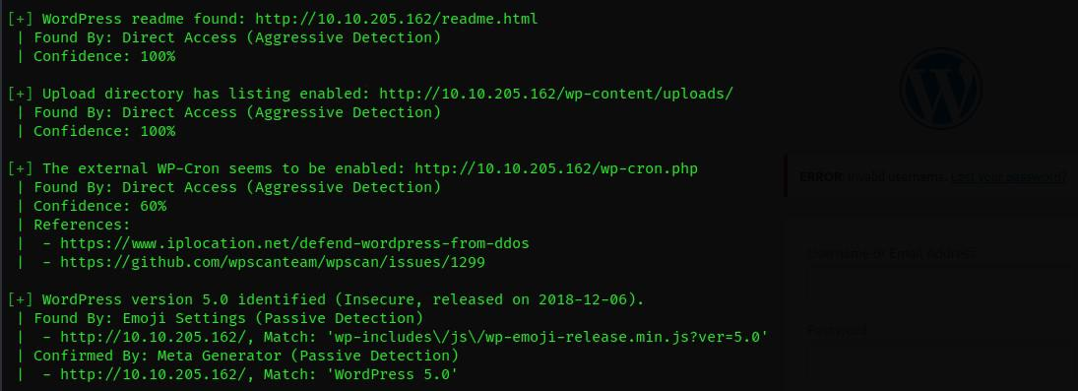

* **–help: (help options)**

wpscan --help

It’s a common practice in Linux to use the “–help” option to get the complete list of the usability of the tool using different switches for different functionalities.

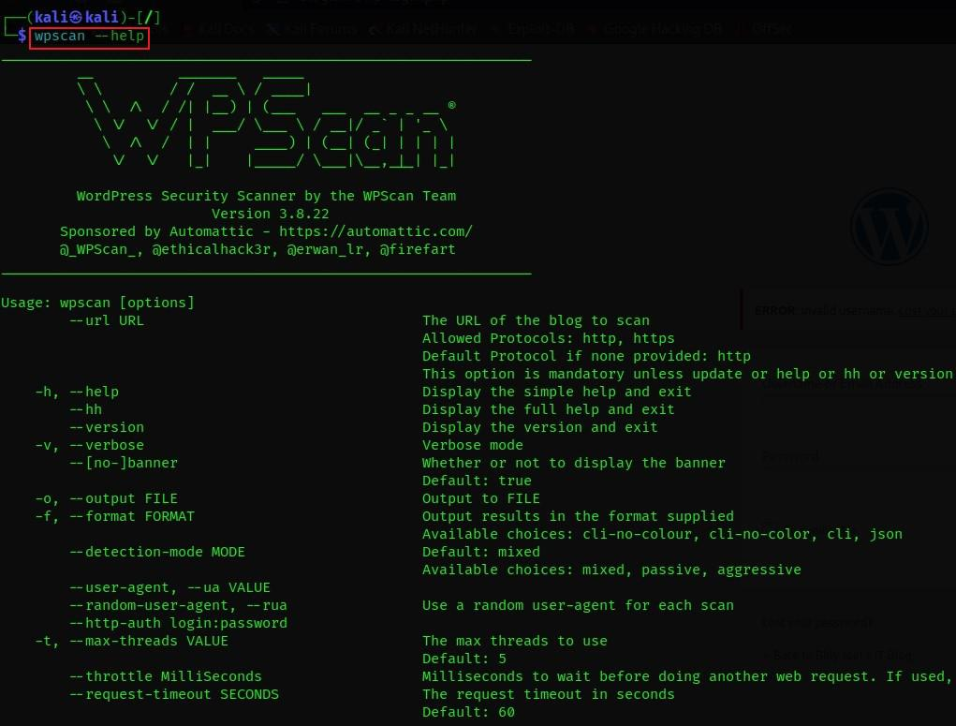

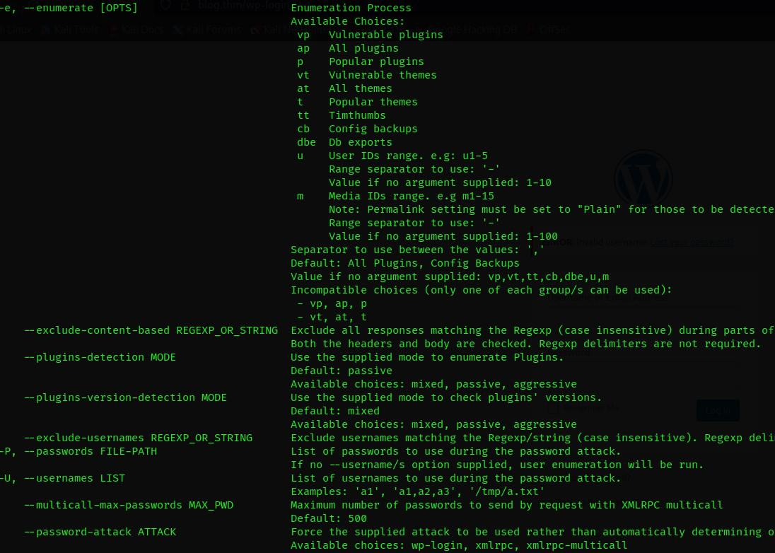

* ***-e u: (enumerating website users)***

*wpscan –url IP_ADDRESS_OF_WEBSITE -e u*

This lets the wpscan tool enumerate the WordPress site for valid login usernames. After the scan, it would give all the usernames the tool has enumerated which are valid users of the WordPress site and are often times brute forced to gain unauthorized access to the WordPress admin/author dashboard.



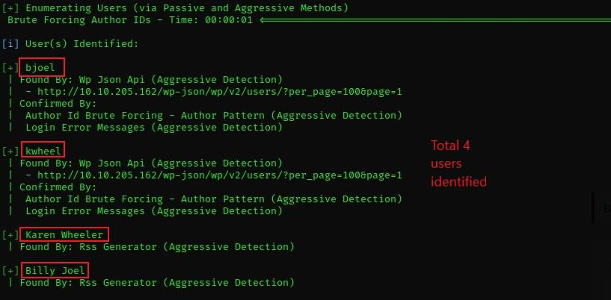

* ***-U -P: (brute-forcing password for the identified user)***

*wpscan –url IP_ADDRESS_OF_WEBSITE -U USER_NAME -P PATH_TO_WORDLIST*

As we managed to enumerate some usernames for the WordPress site above, let’s try to brute-force the user “kwheel”.

* **Brute forcing**: It is a technique where a wordlist is used against a tool that effectively finds the matching password for the given username.
* **Wordlist**: The password cracking tool uses a wordlist, which is nothing but a text file containing a set of commonly used passwords. Ex: 12345678, qwerty, pizza123,etc.

Now let’s try to brute force the user “kwheel”.



*rockyou.txt is a quite commonly used wordlist for brute force attacks.*

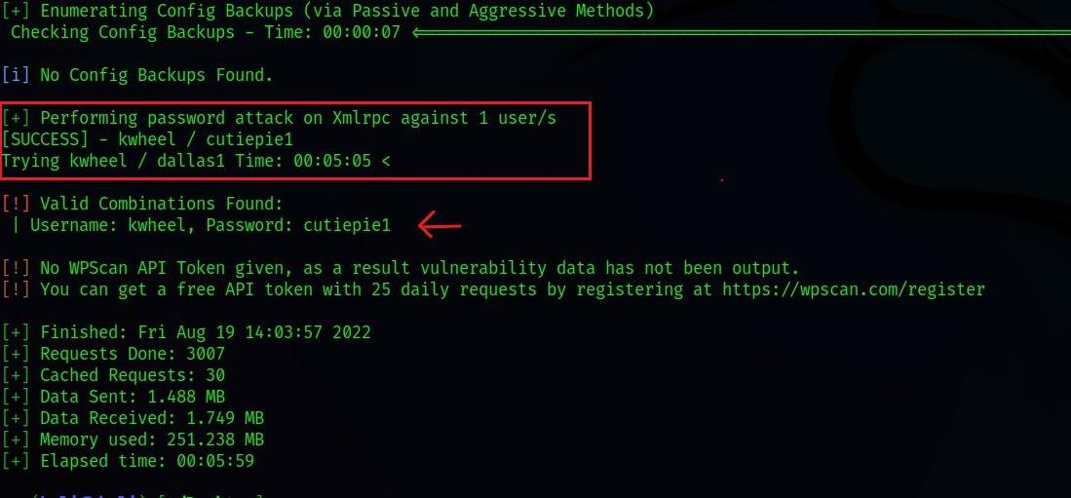

**2. OWASP ZAP**

ZAP has installers for Windows, Linux, and Mac OS/X, as well as Docker images. Download the appropriate installer from the download page and install it on the machine where you will run the penetration test.

Java 8 or higher is required to run ZAP. The Mac OS/X installer includes the appropriate Java version, but Java 8+ must be installed separately for Windows, Linux, and cross-platform versions. The Docker version already includes Java.

When you start ZAP for the first time, you need to choose whether to make the ZAP session persistent. If you persist the session, it will be saved to a local HSQLDB. Otherwise, files will be deleted when you log out of ZAP.

Before proceeding, ensure you have permission from the web application owner to perform a penetration test.

Run a quick start auto scan:

* Start ZAP and click the Quick Launch tab in the workspace window.
* Click the Auto Scan button.
* In the Attack URL text box, enter the full URL of the web application.
* Select either Use traditional spider, Use ajax spider, or both (more details below)
* Click Attack.

1. Click **Attack**.

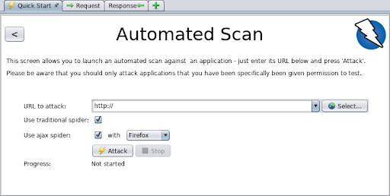

ZAP uses a crawler to go through the web application and scan pages it finds. It then uses the active scanner to attack every page, function, and parameter it finds.

***ZAP-spiders***  
ZAP provides two spiders for scraping web applications, which you can select in the automated scan dialog:

* The traditional ZAP spider inspects HTML in a web application's response to detect links. Although this spider is fast, it is less effective when navigating AJAX web applications that use JavaScript to generate links.
* The ZAP AJAX spider is more effective for JavaScript applications. It navigates a web application by invoking a browser, rendering the full JavaScript of the page, and following any links on the resulting page. AJAX spiders are slower than traditional spiders and require additional configuration to be used in a headless environment.   
  ZAP uses two forms of scanning:
* Passive scanning investigates all proxy requests and responses, but does not change the response in any way and is considered safe. It can be done on a background thread so it doesn't slow down the application. This can find some vulnerabilities and can help you understand the basic security posture of a web application.
* Active scanning attempts to find additional vulnerabilities using known attack vectors against the selected target. Do not use active scans against targets you don't have permission to test, as active scans are real attacks that might cause damage .